FORT HAMILTON HIGH SCHOOL
Kaye Houlihan, Principal
Francine DePrima, Parent Coordinator

ALL PARENTS, STUDENTS AND NEIGHBORS
PLEASE JOIN US
MONDAY, NOVEMBER 9, 2015
PUBLIC TOWN HALL SAFETY MEETING
7:15 P.M.
Presenters:
Mike Kozlowski, AP Security ♦ P.O. Gheith, 68TH Precinct

Topics will include:
School Safety/ CAASS System / ID Cards ♦ Procedures on Safety Drills♦
♦ Update on Neighborhood Watch♦
The town hall meeting will also serve as a forum for citizens to express their concerns and ask questions.

Cyber Bulling: What is it and what can we do to prevent it?
Presenter: Mary Ann Parrish, Guidance Counselor
♦
PARENT TEACHER CONFERENCES
Thursday, November 19th | 6:00 – 8:30 p.m.
Friday, November 20th | 1:00 – 3:00 p.m.
Translators will be available
♦

School closed ♦ thanksgiving day
November 26th & November 27th
♦
REPORT CARDS DISTRIBUTED DECEMBER 8TH
♦
AUDITIONS
FOR THE SPRING MUSICAL

WEDNESDAY, DECEMBER 9TH &
FRIDAY, DECEMBER 11TH AT 4:00 P.M.
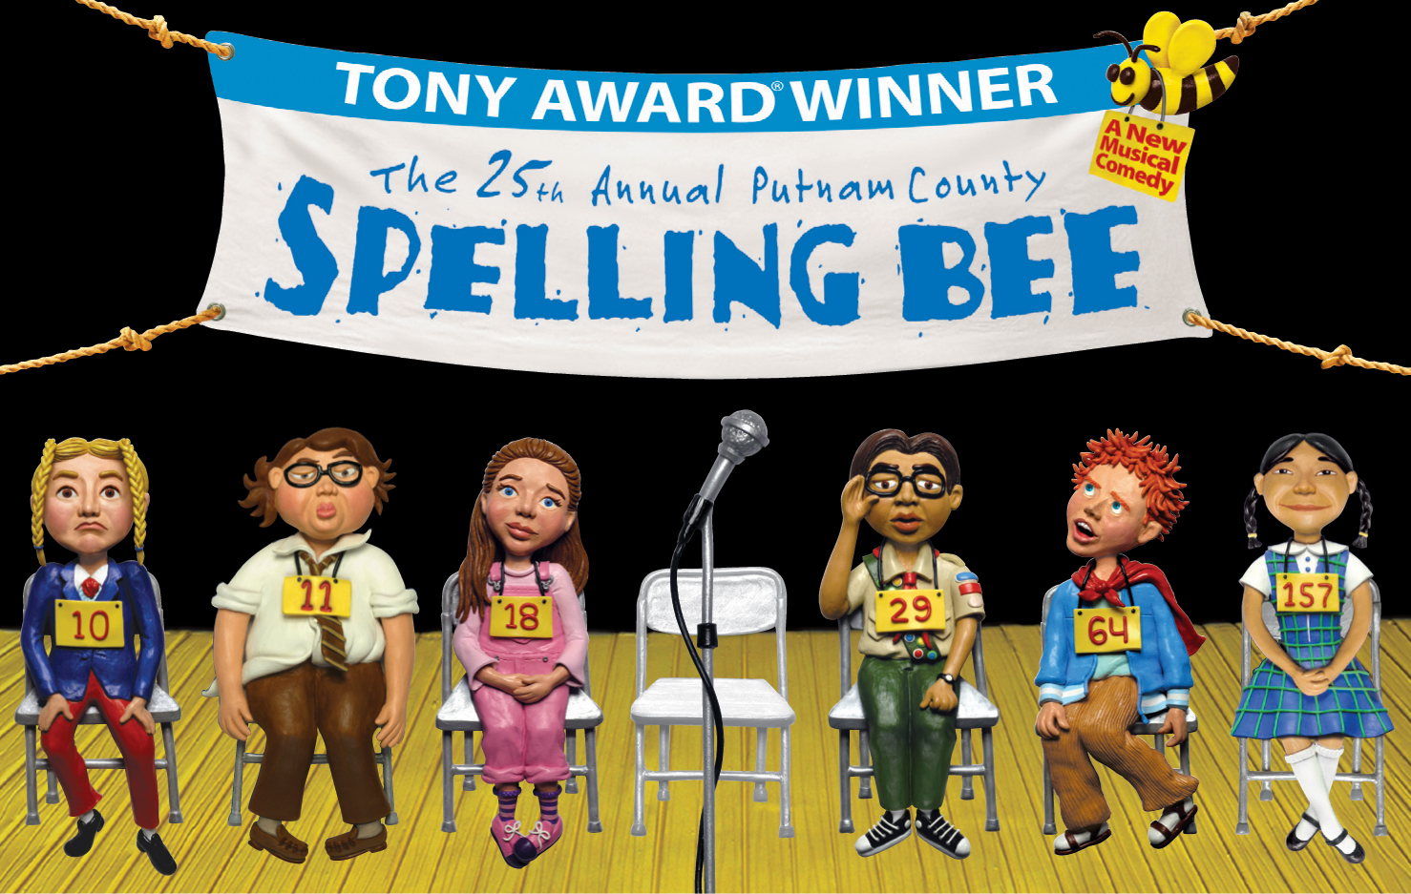
Please see Bill Coulter in the auditorium.
♦
PLEASE JOIN US FOR OUR WINTER SPECTACULAR



Wednesday - December 16TH – 7:00 p.m.
Thursday – December 17TH – 7:00 p.m.

